Pre-Hospital Stroke Checklist for EMS Direct-to-CT Activation for Suspected Stroke Patients

Patient Name:
DOB: Estimated weight:

- Persistent symptoms of sudden-onset neurological dysfunction
- Time Last Known Well (LKW)* is within 24 hours by the estimated time of arrival to hospital
- Positive Prehospital Cincinnati Prehospital Stroke Scale (any abnormal findings)
- Patient is hemodynamically stable with no need for emergent resuscitation
- Blood glucose is greater than 60 mg/dL or corrected to great than 60 mg/dL with persistent neurological symptoms
If all checked, activate the Direct-to-CT^ pathway and state
“EMS Code Stroke, Direct-to-CT” with ETA.

To expedite patient care on arrival:
- FAST-ED Score and 3 lytic questions should be documented and communicate to the ED provider
- Obtain IV access with greater than 20 gauge. If possible, place 2 large-bore antecubital IVs with luer lock preferred (for rapid contrast injection during brain vessel imaging)
- Obtain phone number of contact to call for further questions and medical decision making if necessary
- If possible, remove heavy clothing and jewelry from the patient during transport

*Time LKW is when the patient was last seen without their new neurological deficits. This should not be confused with the time the patient was found with deficits.
^It may be preferable to call ON THE PHONE rather than radio as you may be asked to provide patient information to assist in pre-registration to expedite their care upon arrival to the Emergency Dept.

Decision Support Tools
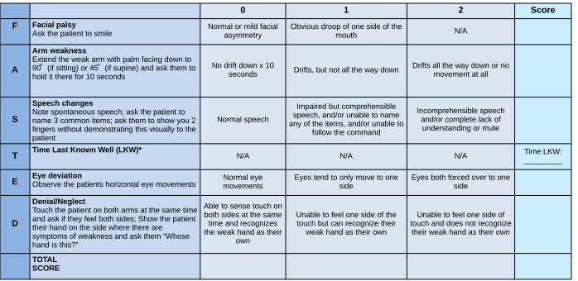
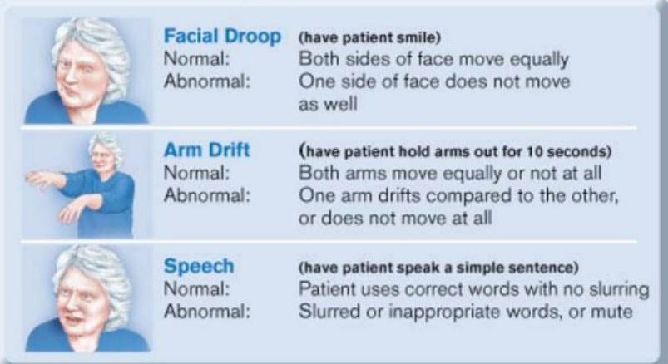
Cincinnati Prehospital Stroke Scale
EMS to ED Transfer of Care
Suggested Minimum Report
- Age/Gender
- Last Known Well
- Symptoms at onset
- Current Symptoms
- BP trends and finger stick glucose
- POSSIBLE contraindications for thrombolytics
- ANY history of bleeding problems
- Taking ANY anticoagulants (oral or injectable)
- Trauma/surgery within 3 months
FAST-ED Screening Tool
List of Anticoagulants
- Rivaroxaban (Xarelto)
- Dabigatran (Pradaxa)
- Apixaban (Eliquis)
- Edoxaban (Savaysa)
- Warfarin (Coumadin, Jantoven)
- Enoxaparin (Lovenox)

*Please note that platelet inhibitors, such as aspirin, clopidogrel (Plavix), ticagrelor (Brilinta), and prasugrel (Effient) are NOT considered anticoagulants.
*Please note that platelet inhibitors, such as aspirin, clopidogrel (Plavix), ticagrelor (Brilinta), and prasugrel (Effient) are NOT anticoagulants.

